- Excite
  - Interpret mood (sleeping)
  - Relate topic
    - Just as important as dress code or having school uniforms
- Launch
  - State theme
    - Too many people walk slow
    - They don’t go or get to class on time
    - The crowd in the halls and leave people aggravated trying to get through all the people loitering
    - There is only one solution automatic stun-guns and speedometers
  - High impact
    - Public participation
      - Raise hands, if you have ever been angry at some one you couldn’t get around
      - Weather it is a group of people walking slow and they spread themselves across the hall
      - Or you yourself are late and people just don’t seem to want to let you through to your class
  - Define
    - What is a stun-gun you ask? They range from 50,000 to 500,000 watts of pure electricity flowing right into the body giving their victim quite a shock.
  - Orient
    - This works in quite a simple way, the speedometer is hooked to the stun-gun and whenever the wearer is moving slower then the set speed the speedometer triggers the stun-gun for a short period of time and causes the victim to jump and make them walk faster.
    - The speedometers set speed can be adjusted such as for handicaps or other difficulties a fine may be issued as well.
  - There is only one way to stop this, we must take action now

  - If we all purchase our own stun-guns to use on others, we are making one giant step towards success. Slow walking will not be tolerated any longer. Please note it is an option to create your own stun gun to use on another person of course it will have to be approved and checked for small explosives and or drug compartments, etc. and it will be tested on you, but you are encouraged to build your own.
  - I will answer pricing questions at the end
- Relate
  - Motivate
    - As you all know other action has been taken such as decreasing passing times to classes, but that does not change those sorry insignificant people that refuse to move faster
    - Drastic measures must be taken
  - What’s in it for us
    - These drastic measures can only benefit all of us
    - Slow people will learn to walk faster because as everyone knows you can’t go through life being slow
    - Fast walking people will no longer end up in class nearly late and aggravated
  - As I asked how many of you have been stuck behind a SLOW WALKER, most of you responded yes, the others were sleeping, well you should all know what it feels like so don’t ever let it happen again.
- Influence
  - The smartest way to solve all of our problems is to fight them.
    - Change them
    - Don’t give in
    - Take action, be more aggressive
  - If only those stun guns could talk, I believe they would be telling us to purchase them. Once that is done they would tell us the shoot people with them. Everyone would have one so why should it matter if we pull the trigger on a couple of victims here or there, if they needed to they could defend themselves with their own.
- Reiterate
  - If anyone has any questions
    - Prices (poster)
  - What they have learned
    - We have gone over reasoning for taking action
    - Why this is the smartest way to deal with loitering and other hall time offences
    - Different options for going about stunning (automatic and personal)
  - These are the only alternatives we must take action now
- Energize
  - High impact
    - Take action, buy your own, take action, encourage student council or the rest of the staff to buy stun guns, take action now while we still can. Do not let this terrorism continue
    - This is no joke and it should not be allowed to continue
  - Conclude
    - Only you can change things, and if we do not get together and change it, no body can.
    - Thank you for your time
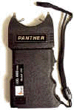
100,000 Volts
$17.49
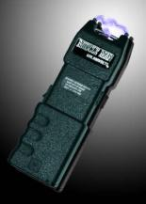
600,000 Volts
$74.89
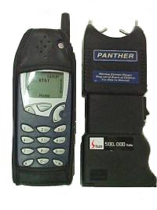
500,000 Volts
$32.95

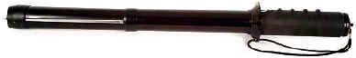
Classic Baton
500,000
$48.95
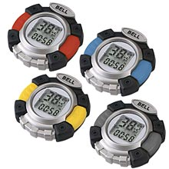
Speedometer
$16.98

